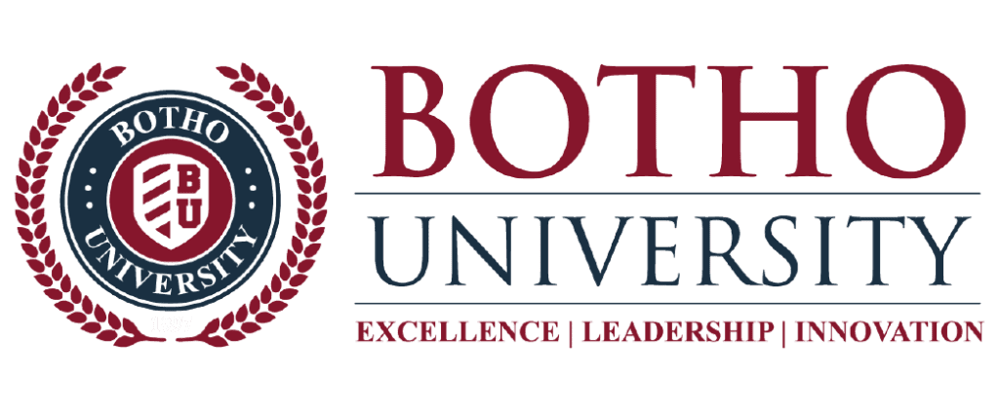
COMMUNICATION AND TECHNICAL WRITING

Submitted by: LATOYA TSHIAMO BARENG DINTWE
Student ID: 2602407
Lecturer: Mr. Mokoka
Module: Communication and technical writing
Batch number: D5-CTW-23
Date: 28 September 2026

Cultural Differences in Plagiarism

Introduction
Plagiarism is the act of using someone else’s work without giving them credit. This essay presents an overview of how attitudes toward plagiarism differ across countries and also a brief discussion on how the issues of plagiarism are specifically addressed in Botswana.

Plagiarism in Different Countries
Perceptions of plagiarism differ across countries because educational traditions, cultural values, and historical experiences influence how people understand academic ownership. In Western academic environments, particularly in countries such as the United States and United Kingdom, originality and individual authorship are strongly valued. Students are therefore expected to acknowledge other people's ideas through appropriate referencing, and plagiarism is generally treated as serious academic misconduct. (PlagPointer Research Team,2025)
In some East Asian educational contexts, traditional approaches to learning have placed greater emphasis on memorising and reproducing the work of respected scholars. These practices can sometimes create differences in how students understand authorship and citation. However, attitudes are changing as universities increasingly promote international academic-integrity standards and teach students about proper attribution. (Campbell,2017)
Awareness and enforcement of plagiarism rules have historically varied in parts of Eastern Europe and Latin America. Nevertheless, universities in these regions have increasingly introduced academic-integrity policies, plagiarism-detection systems, and educational initiatives aimed at encouraging proper acknowledgement of sources. (PlagPointer Research Team,2025)
In parts of Africa and the Middle East, factors such as differences in educational practices, limited training in referencing, language difficulties, and access to academic resources may influence students' understanding of plagiarism. This does not necessarily mean that students approve of academic dishonesty. Instead, some cases may result from insufficient knowledge of citation and paraphrasing requirements. Academic institutions in these regions are also increasingly strengthening their approaches to academic integrity. (PlagPointer Research Team,2025)

